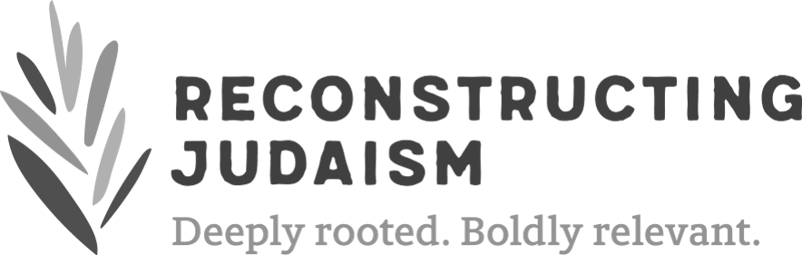

2018

Reconstructing Judaism Convention
Covenant of Behavior

As Reconstructing Judaism sets about building our own learning, caring and respectful “pop-up” kehillah kedoshah – holy community - for this convention, we draw from the Camp Havaya and Havaya Arts model of community covenant for our inspiration and aspiration of how we hope “to be.”

We present a modified version of the Havaya Summer Programs Covenant of Behavior and expectations as norms and values we hope participants in the convention will observe to create a positive experience for all attendees. May our values guide our actions as we move through our days and nights during convention.

Covenant of Behavior
Be supportive and courteous. • Be open-minded and kind. • Try to make friends. • Don’t be judgmental. • Be understanding and mindful of others. • Be your unique self. • Be appreciative of others. • Be flexible. • Be aware of your surroundings. • Appreciate diversity. • Respect confidentiality and honesty.

We expect participants:
• To recognize their responsibility -- for themselves and to those around them.
• To respect themselves and others -- others’ perspectives and personal space.
• To accept accountability for their actions and the consequences, both positive and negative, of their behavior.

We will not accept behaviors such as:
Bullying • Disrespect • Bigotry (including, but not limited to: racism, sexism, ableism, transphobia and homophobia) • Harassment of any kind • Violence • Any unsafe behaviors that are potentially harmful to one’s self or others. Commission of any of these behaviors could result in removal from the convention.

Reconstructing Judaism Endorses
Reconstructing Judaism encourages respectful, dignified and welcomed interactions between participants. We believe that every member of our community has the right to learn, pray, and socialize in a setting free of harassment and bullying. We encourage all participants at convention to practice respectful and civil behavior, both in communication and in conduct.

Affirmative Consent
We are proponents of affirmative consent. It is the responsibility of the person initiating or escalating physical contact to gain verbal consent, in advance, to confirm that the desired interaction is consensual.

What to do next?
Support is available should you need it. If you have witnessed or experienced harassment or bullying during this event, we encourage you to report the unwelcome conduct to Reconstructing Judaism staff immediately at the registration table. Volunteer chaplains will be on-call during convention should a need arise. We are committed to taking the necessary steps to ensure that any matter receives prompt attention.

If your situation requires more critical attention, please call 911 or ask a staff member to call 911 for you.

Whether you are attending convention as a lay-leader, staff member of Reconstructing Judaism or one of our many affiliates, volunteers, presenters or curious explorers, we thank you for your partnership in sharing the responsibility to make this convention a positive experience for all members of our community.

